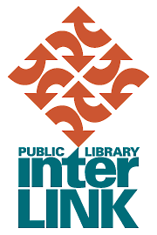

FOR IMMEDIATE RELEASE: December 22, 2014

Just Ask chat service will close December 31, 2014

Just Ask, a collaborative chat service provided by members of the Public Library InterLINK (InterLINK) federation since September 2011, will close on December 31, 2014.

Just Ask was established as a pilot project to provide an alternate way for public library patrons to have their information needs met. InterLINK and its member libraries provided funding for Just Ask and participating libraries staffed the service.

Since the launch of the service in September 2011, Just Ask has fielded just over 25,000 questions. In 2013, the Just Ask service answered 8,008 questions. This represents 0.36% of the 2.2 million questions that the participating libraries fielded in total.

InterLINK’s member libraries continue to work to provide the most effective methods of providing information to their communities. Just Ask funding and staff time will be allocated to those services.

Public Library InterLINK is a federation of eighteen public libraries serving south-western British Columbia. InterLINK’s member libraries, serving communities from along the Sea to Sky Highway, throughout Metro Vancouver, the Sunshine Coast and to the Fraser Valley, serve close to 2/3 of the province’s residents. InterLINK works with its member libraries to provide open access to library collections and to develop and deliver collaborative programs that benefit those residents.

To find out more about the services in InterLINK member libraries, please visit your local library’s website. A listing is available at http://www.interlinklibraries.ca/member-libraries.

For more information, contact:

Michael Burris
Executive Director
Public Library InterLINK
mburris@interlinklibraries.ca
604-437-8441

